**LAB 1 OUTPUT:**

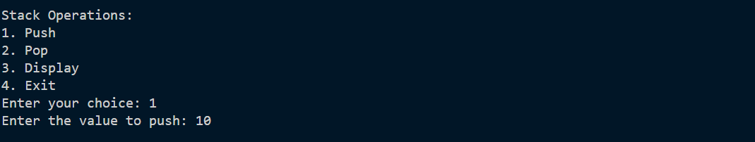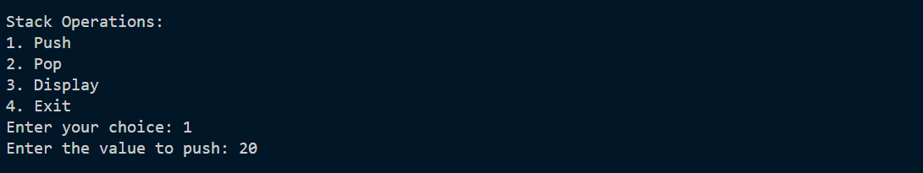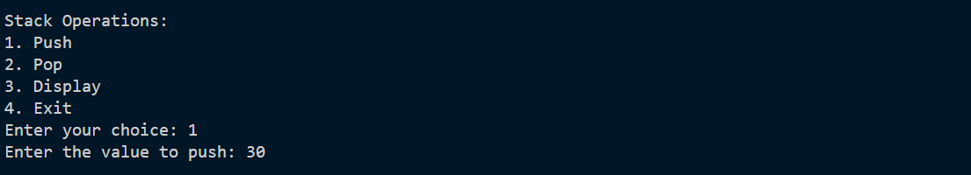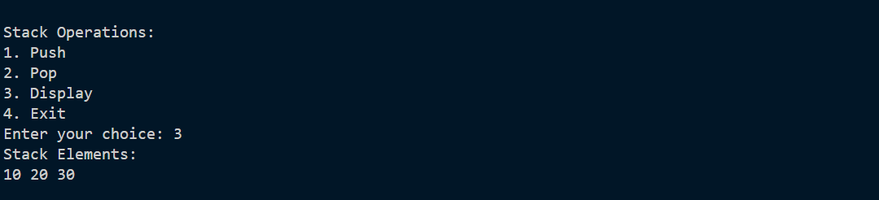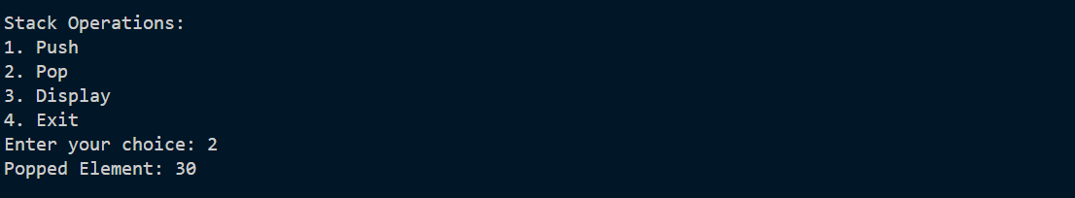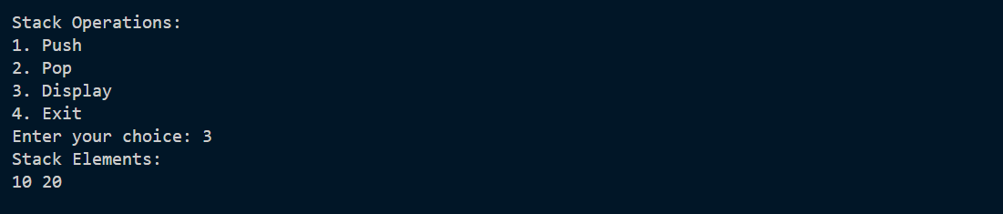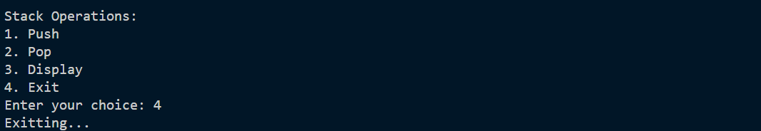

LAB 2, 3, 6, 7, 8, 9, 10, 11, 12, 13, 14, 15

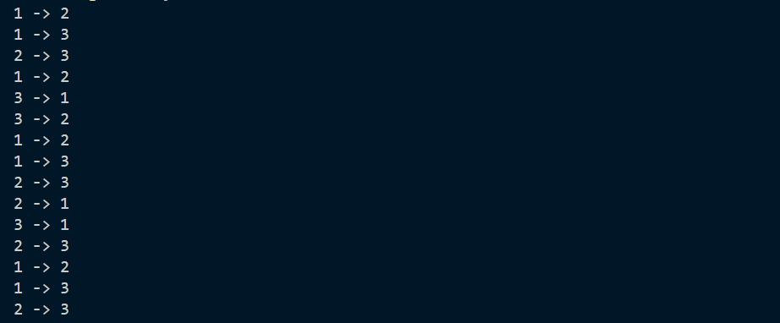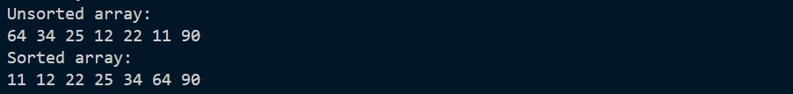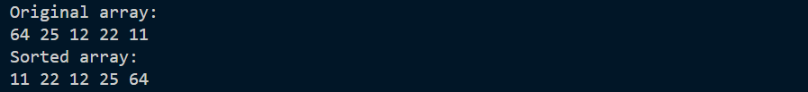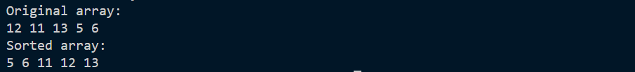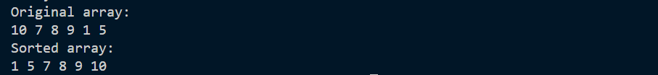

LAB 4 OUTPUT:

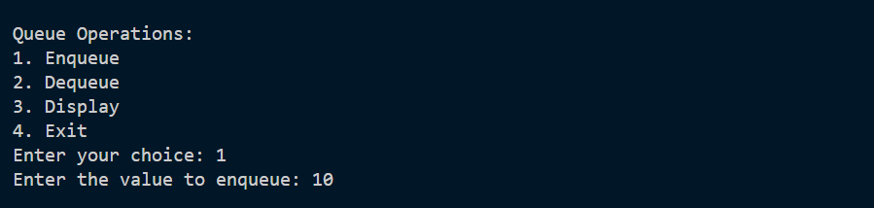

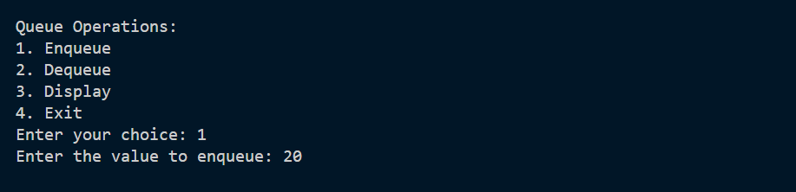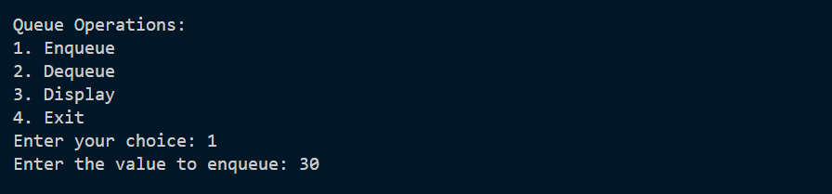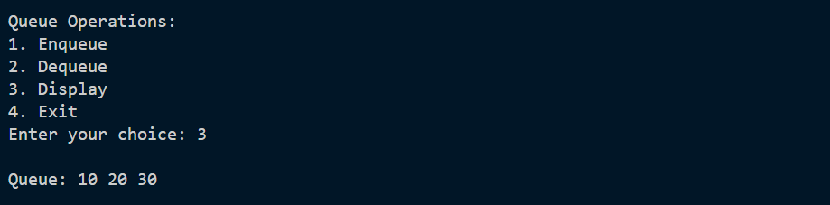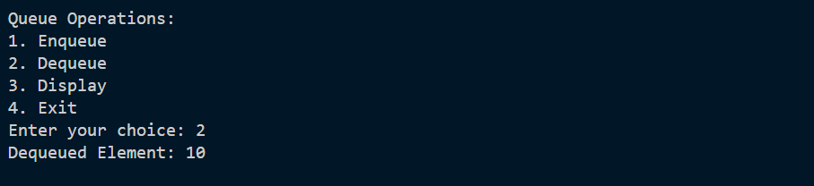

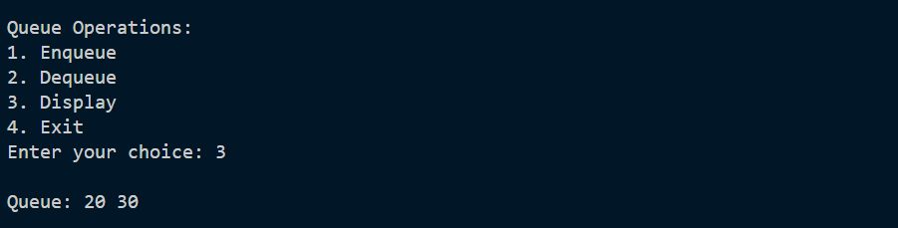

**LAB 5 OUTPUT:**

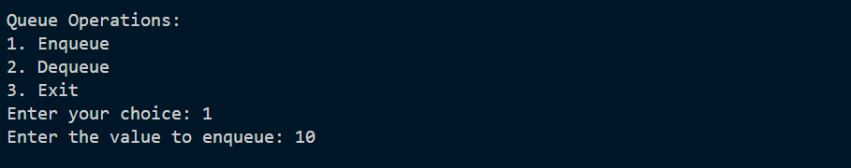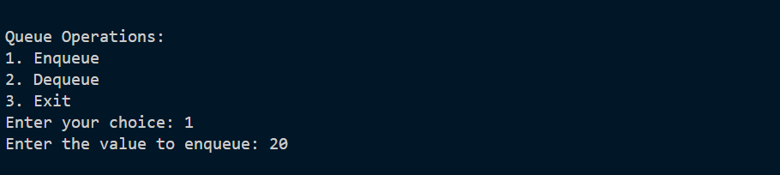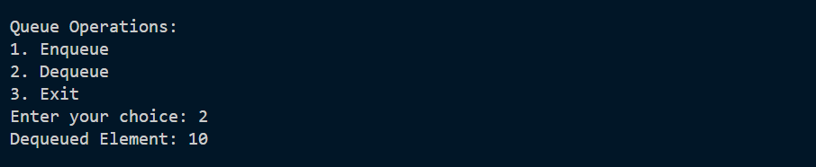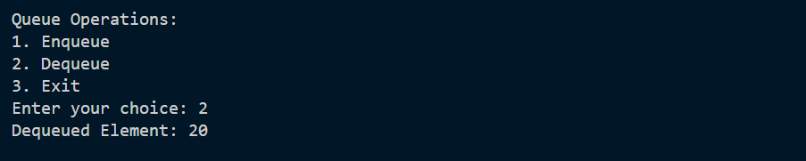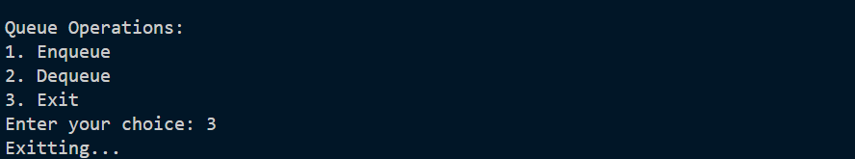

**LAB 16, 17:**

